**DIAMOND**

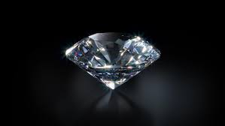

**Name:** Star Diamond

**Brand:**  Harry Winston

**Model#:** 002

**Color:** Transparent

**Price: $71 million**